New Website Photo & Icons Checklist

**Instructions:** Each of the non-bolded Items needs a photo. Think about the context of what kind of page the image is going on and what section it’s going in. Use images from Unsplash and realistic (lifestyle) - non posed - images that lean away from “corporate stock photography.”

Once you have found a photo for a specific page, download it, and save it in the folder for the appropriate page within the folder system in **\mortgagecenter.com\Employee Resources - Marketing Department\Website 2024**. If for some reason you are unable to download an image, put the url of the page you found it on and Chris Edmonds will take care of it.

Once you have added a photo to the folder, please type “Done - Your Initials - DD/MM/YY

* IF you are adding a link, don’t worry about this, just paste the link beside the label.

See “Logo” below under “Standard Page Menu Elements” for an example

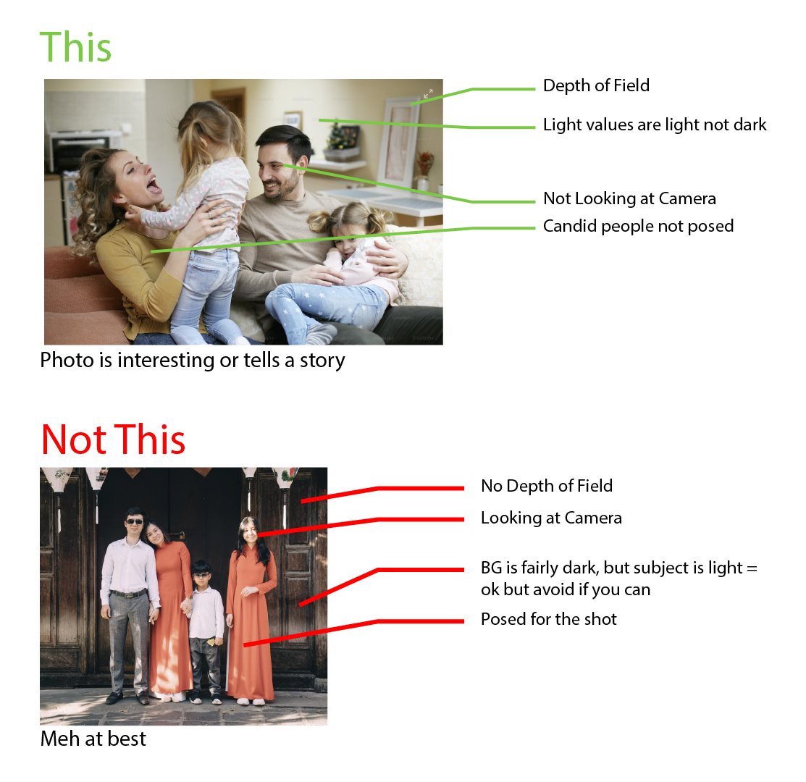

# **Standard Page Menu Elements**

Logo Done **- Done - CE - 4/10/24**

Magnifying glass “Search” icon – [Done](https://mortgagecenter.sharepoint.com/:u:/s/MortgageCenterFiles/EYgiLEPfozhHv-V0HH3lIz4BSnETAupzcU5HaHOmHlpOGg?e=Enfvps) – KL – 4/15/2024

# **Cross Page Elements**

What Mortgage Is Right For Me – header image

“Other Suggested Products”

* Blog Titles – Done – KL- 4/16/2024
* Latest Webinar – Done – KL – 4/16/2024
* MC In the News – Done – KL – 4/16/2024
* Featured Calculator – Done – KL – 4/16/2024
* Featured Toolkit – Done – KL – 4/16/2024

Downloadable Tools with phone mask – grabbing a screenshot of product, in the shape of a phone

Blog Photos – supporting in-blog images

# **Standard Page Closing Elements**

About Us – Chris has image for this

Get In Touch – Done – KL – 4/16/2024

Apply Today or Request a Call – Done – KL – 4/16/2024

Google Reviews – Done – KL – 4/16/2024

Footer

# 

# **New Applications**

## **All Products Page**

Header Photo – Done – KL – 04/16/2024

### **Individual Product Page**

Header Photo for each product

* Purchase
  + Conventional – Done – KL – 04/16/2024
  + FHA – Done – KL – 04/16/2024
  + VA – Done – KL – 04/16/2024
  + PMI Saver – Done – KL – 04/16/2024
  + Jumbo – Done – KL – 04/16/2024
  + Construction – Done – KL – 04/16/2024
  + HomeReady – Done – KL – 04/16/2024
  + RightChoice Home Loan – Done – KL – 04/16/2024
  + Home Renovation – Done – KL – 04/16/2024
  + Zero Down Payment – Done – KL – 04/16/2024
  + Doctor Loan – Done – KL – 04/16/2024
  + Student Debt Relief – Done – KL – 04/16/2024
  + Manufactured Home – Done – KL – 04/16/2024
  + Hobby Farm – Done – KL – 04/16/2024
  + Condo Loan – Done – KL – 04/16/2024 -
  + Best Score Family Helper – Done – KL – 04/16/2024
* Refinance
  + Conventional – Done – KL – 04/16/2024
  + FHA – Done – KL – 04/16/2024
  + VA – Done – KL – 04/16/2024
  + PMI – Done – KL – 04/16/2024
  + Condo – Done – KL – 04/16/2024 -
  + Max cash-out refinance – Done – KL – 04/16/2024
  + Right Choice – Done – KL – 04/16/2024
  + Home Renovation – Done – KL – 04/16/2024
  + Jumbo Loan – Done – KL – 04/16/2024
  + Hobby Farm – Done – KL – 04/16/2024
* Home Equity – Done – KL – 04/16/2024

“Current Rate Configurations” Rate **Icons**

* 30 Fixed
* 15 Fixed
* 7/1Arm
* 5/1Arm

Note: Was not able to find any pre-existing icons that would work well for this. We may need to take a generic icon pack like [this one](https://iconscout.com/icon-pack/mortgage-10) and add product-specific features

“High Level Product Features” (4 icons per product, icons are BENEFIT focused) –

Note: This may need further discussion. I’m assuming we can’t do 4 different icons each for 18 different products, so we will probably need to create some broad-ish categories of benefit, and then assign 4 of those categories to each loan.

# **What Mortgage Is Right For Me?**

Header Opening Photo - Done – KL – 04/16/2024

Use Product Header Photo from individual product page for each suggested product

Apply Today or Request a Call - Done – KL – 04/16/2024

# **First Time Home Buyer**

### **FTHB Page**

Header Photo / Video - Done – KL – 04/16/2024

Downloadable Tools - Image will fit into a phone mask - Done – KL – 04/16/2024

Feature Icons - - Done – KL – 04/16/2024

BC Demo Video

Team Member Highlights – these images will be existing headshots of LOs

# **Misc & Support**

### **LO Pages**

LO Photos with Hexagon

Quick Facts Icons - Done – KL – 04/16/2024

* Briefcase
* Weight
* Guitar
* Football
* Soccerball
* Baby
* Toddler
* Cell Phone
* Cell Phone - Texting

### **Support**

Popular Support Topics Icons - Done – KL – 04/16/2024

* Calendar
* Email
* Chat

### **Rates Page**

[Header Img](https://www.istockphoto.com/photo/mortgage-calculator-or-real-estate-business-concept-gm1363734054-435180808) - Done – KL – 04/16/2024 – could not find an Unsplash image for this

### **Rates Assumptions Page**

Header Img - Done – KL – 04/16/2024

### **Calculator Page**

No additional photos needed at this time

### **Careers Page –**

Featured Job – Use photo from job category?

Benefits Img

Work Environment

Hiring Process

How We Manage

Career & Compensation

Employee Value Prop

Culture Guide

Glass door logo

Need photos for job categories

* Origination
* Member Services
* Accounting
* Compliance
* Etc.

### **Revenue Partner Page - Phase 2**

# **About Us / General Info**

### **MC in the News**

Article Header Imgs to be used on this page

### **About Us –** Per discussion w/ Chris, these will be MC-sourced images

Header

About Us

Awards & Articles

Leadership & Team Member Highlights

### **Stand Alone Contact Page**

Header – Should be image of MC (either outside of building or internal pic of inside the business)

### **404 - Not Found**

Background + Icon - Done – KL – 04/17/2024

# **Existing Accounts**

### **Existing / Member Services**

### **Home**

Quick Nav Imgs - Use same for sections

* Make a Payment
* Hardship Assistance
* Setup Autopay
* Support Desk - Done – KL – 04/17/2024

Autopay Setup Video

### **Make a Payment**

Header Img / Video - Done – KL – 04/17/2024

Blog Article imgs

### **Hardship Assistance**

Header Img - Done – KL – 04/17/2024

Hardship Assistance Icons 4 of them - Done – KL – 04/17/2024

# **Credit Union Partners**

### **CU Partners**

Header Video

What we do Icons (4) – *Need access to the fig board to see what these are*

Other benefits (4) –

* Tech Offerings
* Marketing Support
* 3
* 4

Keri’s Photo

Josh’s Photo

### **CU Partners Secret Page**

MC in the news photo that goes with the article

MC Assets img or icon

### **CU Partners Referral Page**

Header Image - Done – KL – 04/17/2024

Form

# **Mortgage University**

### **Mortgage U - Main**

Featured Article Img

Downloadable tools in phone mask –

### **All Blogs Page**

Header img - Done – KL – 04/17/2024

### **Individual Blog Pages**

Header Img – *Are we swapping out all of the existing blog images for new ones on the new site?*

Background image for dynamic area - this will parallax - Done – KL – 04/17/2024

Downloadable Tools with phone mask